**DIFFERENCE BETWEEN EMIGRATION AND IMMIGRATION**

**https://24x7offshoring.com/**

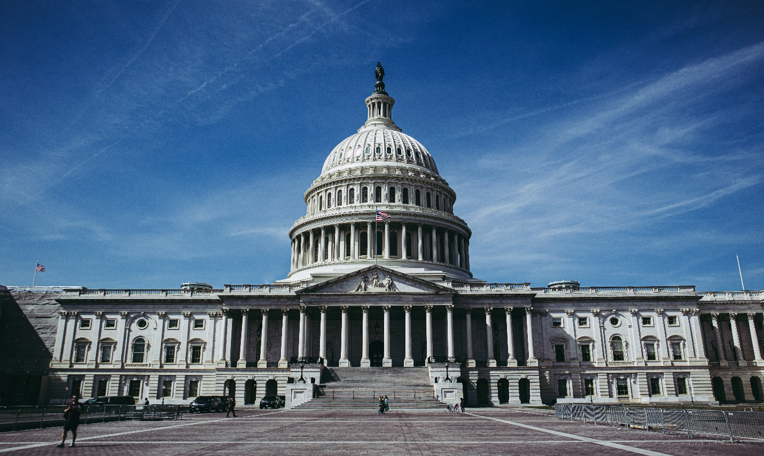 [**http://24x7outsourcing.com/**](http://24x7outsourcing.com/)

**Understanding the Differences between Migration, Emigration, and Immigration**

Everyone on the planet needs to improve personal satisfaction, regardless of whether as far as financial, religion, training, and social viewpoint. Every one of these words like relocation, migration, and movement are identified with development.

**What is Migration and who are transients**

The term traveler is related with the word foreigner and wanderer and it began from Latin. The Latin word relocate intends to move starting with one spot then onto the next and brought about the development of words like travelers and move. You can utilize the word relocation when you need to tell about individuals who are moving to the new spot and they would prefer not to tell where they came from and where they are moving. Relocation isn't tied in with living in the new spot for eternity.

**What is Immigration and who are workers**

A worker is an individual who moves to another nation forever and needs the identity of that country. They leave their local country for better future freedoms.

The movement is the demonstration of moving to another country. The most ideal approach to recollect this word is, recall its prefix imim. Imim is gotten from the Latin word which portrays that a foreigner is an individual who comes into another country. This word applies just to individuals.

**What is Emigration and who are displaced people**

Displacement is the way toward living in the area or country, so a traveler is an individual who leaves for different nations. It is additionally a perpetual move. Its prefix is e in the Latin language that implies out of.

**Migration and Immigration**

The intriguing part is that an individual can be a settler and migrant both. For Instance, when George moved from Texas to Sweden, he was a traveler from Texas and a worker to Sweden. The relational word changes the implications of the words.

A settler is heading off to some place, and an exiled person is from some place. Albeit the two words identify with development, their precise importance lies in their application.

Basically, resettlement implies leaving the nation to get comfortable the unfamiliar land for all time, and migration implies entering the country and settling there forever.

**Impacts of Immigration**

Outsiders are an extraordinary wellspring of bringing monetary, social, and social advantages to different nations.

It has additionally brought about the rise of multicultural social orders.

The USA is the state where individuals from one side of the planet to the other come to live for all time.

The quantity of individuals from various identities has improved the way of life of the USA and that is the reason it is known as a blend.

The migration interaction is exceptionally extensive and dreary, and it requires monstrous desk work. One of the significant prerequisites is that every one of the archives that are not in English should be converted into English by guaranteed interpretations.

**Impacts of Emigration**

At the point when individuals move to another nation, spending on purchaser items and the quantity of workforces descends. Your nation will profit by this if the work market is oversaturated and it will drop down the joblessness rate.

**Impacts of Migration**

Relocation is the development of individuals starting with one lasting home then onto the next. Individuals frequently have a decision to move, however now and again, they are compelled to move. The justification leaving the spot is known as the push factor.

**DIFFERENCE BETWEEN EMIGRATION AND IMMIGRATION**

**https://24x7offshoring.com/**

**http://24x7outsourcing.com/**